MSDS 6306: Introduction to Data Science - Live session Unit 01 Assignment

### 1)

1. log(10) = 2.3025851
2. ?log(): description says that log() default is the natural log. Using base 10: log(10, base = 10) = 1
3. Log(-10) = NaN Cannot take the log of a negative number. The log curve is asymptotic to negative infinity as x approaches zero(log(0) = -\infty{}
4. sqrt(4) = 2

### 2)

a.

rNormVector <- rnorm(15)  
mean(rNormVector)

## [1] 0.09415648

sd(rNormVector)

## [1] 1.346474

b.

rNormVector <- rnorm(15,mean = 10,sd = 2)  
mean(rNormVector)

## [1] 9.275331

sd(rNormVector)

## [1] 1.343167

1. The values are randomly sampled fromt he distribution so the exact values will not match. As the sample size increases the mean will get closer to the actual mean.

### 3)

indWeight <- c(60, 72, 57, 90, 95, 72)  
indHeight <- c(1.80, 1.85, 1.72, 1.90, 1.74, 1.91)   
plot(indWeight, indHeight) # Weight and height would seem to be positivly related

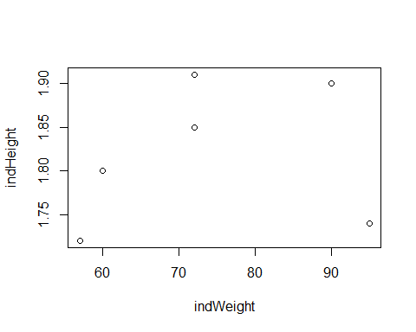

indBMI <- indWeight / sqrt(indHeight)  
sum(mean(indWeight) - indWeight)

## [1] -2.842171e-14

### 4)

brychan <- data.frame(  
 area = c("computer programming", "math", "statistics", "machine learning", "domain expertise",   
 "communication and \npresentation skills", "data visualization"),  
 rank = c(3, 4, 3, 2, 4, 2, 4)  
 )  
par(mar = c(10,2,2,2))  
barplot(brychan$rank, names.arg = brychan$area,las=2)

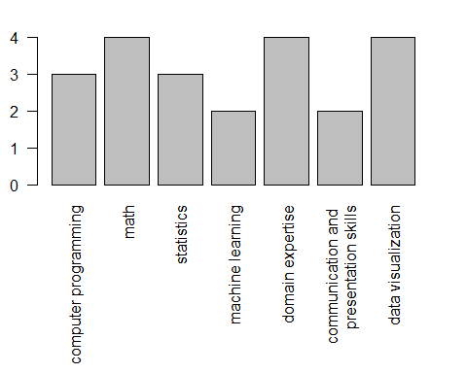

### 5)

rm(list = ls()) # swirl suggest removing all workspace variables

library(swirl)

swirl()

#R Programing - mod 1

5+7

x <- 5+7

x

y <- x - 3

y

z <- c(1.1, 9, 3.14)

?c

z

c(z,555,z)

z * 2 + 100

my_sqrt <- sqrt(z - 1)

my_sqrt

my_div <- z / my_sqrt

my_div

c(1, 2, 3, 4) + c(0, 10)

c(1, 2, 3, 4) + c(0, 10, 100)

#R Programing - mod 2

getwd()

ls()

x <- 9

ls()

list.files()

?list.files

args(list.files)

old.dir <- getwd()

dir.create("testdir")

setwd("testdir")

file.create( "mytest.R")

list.files()

file.exists("mytest.R")

file.info("mytest.R")

file.rename("mytest.R", "mytest2.R")

file.copy("mytest2.R", "mytest3.R")

file.path("folder1","folder2")

?dir.create

dir.create(file.path('testdir2', 'testdir3'), recursive = TRUE)

setwd(old.dir)

#R Programing - mod 3

1:20

pi:10

15:1

?":"

seq(1, 20)

my_seq <- seq(5, 10, length=30)

length(my_seq)

1:length(my_seq)

seq(along.with = my_seq)

seq_along(my_seq)

rep(0, times = 40)

rep(c(0, 1, 2), times = 10)

rep(c(0, 1, 2), each = 10)

#R Programing - mod 4

num_vect <- c( 0.5, 55, -10, 6)

tf <- num_vect < 1

tf

num_vect >= 6

my_char <- c("My", "name", "is")

my_char

paste(my_char, collapse = " ")

my_name <- c(my_char, "Brychan")

my_name

paste(my_name, collapse = " ")

paste("Hello", "world!", sep = " ")

paste(1:3, c("X", "Y", "Z"), sep="")

paste(LETTERS, 1:4, sep = "-")

#R Programing - mod 5

x <- c(44, NA, 5, NA)

x*3

y <- rnorm(1000)

z <- rep(NA, 1000)

my_data <- sample(c(y, z), 100)

is.na(my_data)

my_na <- is.na(my_data)

my_na

my_data == NA

sum(my_na)

my_data

0/0

Inf-Inf

#R Programing - mod 6

x <- sample(c(rnorm(20), rep(NA,20)), 20)

x[1:10]

x[is.na(x)]

y <- x[!is.na(x)]

y

y[y > 0]

x[x > 0]

x[!is.na(x) & x > 0]

x[c(3,5,7)]

x[0]

x[3000]

x[c(-2, -10)]

x[-c(2, 10)]

vect <- c(foo = 11, bar = 2, norf = NA)

vect

names(vect)

vect2 <- c(11, 2, NA)

names(vect2) <- c("foo", "bar", "norf")

identical(vect, vect2)

vect["bar"]

vect[c("foo", "bar")]

#R Programing - mod 7

my_vector <- 1:20

my_vector

length(my_vector)

dim(my_vector) <- c(4, 5)

dim(my_vector)

attributes(my_vector)

my_vector

class(my_vector)

my_matrix <- my_vector

?matrix

my_matrix2 <- matrix(1:20, 4, 5)

identical(my_matrix, my_matrix2)

patients <- c("Bill", "Gina", "Kelly", "Sean")

cbind(patients, my_matrix)

my_data <- data.frame(patients, my_matrix)

my_data

class(my_data)

cnames <- c("patient", "age", "weight", "bp", "rating", "test")

colnames(my_data) <- cnames

my_data